**Description**

Product Name: A membrane in a roll with applied and dried reagents for the production of rapid immunochromatographic tests.

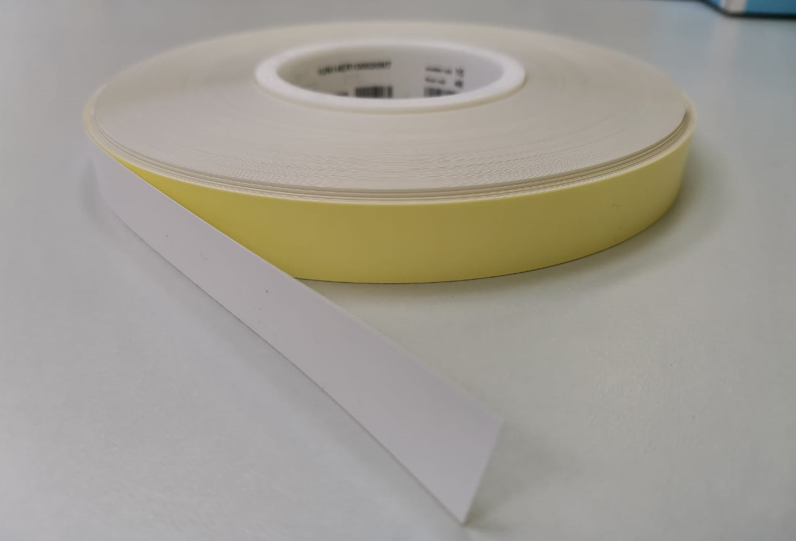

Description**:** Master Membrane

The membrane is a polyester film

coated with a porous cellulose

nitrate material (UN 14ER050020—B).

The tape is 100m long and 20 mm wide.

The membrane with applied reagents

from IMLAB LTD is rolled up.

1)**Master Membrane Morphine Roll 20mm x 100m Catalog number: СSMB – MOR**

A membrane of 20mm x 100m in a roll with applied and dried reagents for the production of rapid immunochromatographic tests for the detection of Morphine in urine.

Product composition:

|  |  |  |
| --- | --- | --- |
| Component | Structure | Quantity |
| The membrane is in a roll with applied reagents. **Membrane with**  **applied reagents MOR**  (**LOT 14С240705**) | Polyester film coated with a porous cellulose nitrate material (UN 14ER050020—B).  The tape is 100 m long and 20 mm wide in a roll. | 11 |
| Morphine conjugate with a protein carrier (BSA)  Test area, first line (components of the main reaction) | 88 mg |
| Polyclonal antibodies of goat to mouse immunoglobulin.  Control area, the second  line (components of the standard reaction) | 88 mg |
| Packaging | Plastic bag |  |

2)**Master Membrane Barbiturates Roll 20mm x 100m Catalog number: СSMB – BAR** A membrane in a roll with applied and dried reagents for the production of rapid immunochromatographic tests for the detection of Barbiturates in urine.

Product composition:

|  |  |  |
| --- | --- | --- |
| Component | Structure | Quantity |
| The membrane is in a roll with applied reagents.  **Membrane with**  **applied reagents BAR**  (**LOT 14С240709**) | Polyester film coated with a porous cellulose nitrate material  (UN 14ER050020—B).  The tape is 100 m long and 20 mm wide in a roll. | 10 |
| Barbiturate Conjugate with a protein carrier (BSA)  Test area, first line (components of the main reaction) | 80 mg |
| Polyclonal antibodies of goat to mouse immunoglobulin.  Control area, the second  line (components of the standard reaction) | 60 mg |
| Packaging | Plastic bag |  |

3) **Master Membrane Benzodiazepines Roll 20mm x 100m Catalog number: СSMB – BZO** A Membrane in a roll with applied and dried reagents for the production of rapid immunochromatographic tests for detecting Benzodiazepine in urine.

Product composition:

|  |  |  |
| --- | --- | --- |
| Component | Structure | Quantity |
| The membrane is in a roll with applied reagents.  **Membrane with**  **applied reagents BZO**  (**LOT 14С240706**) | Polyester film coated with a porous cellulose nitrate material (UN 14ER050020—B).  The tape is 100 m long and 20 mm wide in a roll. | 11 |
| Benzodiazepine conjugate with a protein carrier (BSA)  Test area, first line (components of the main reaction) | 88 mg |
| Polyclonal antibodies of goat to  mouse immunoglobulin. Control area, the second  line (components of the standard reaction) | 110 mg |
| Packaging | Plastic bag |  |

4)**Master Membrane Cocaine Roll 20mm x 100m Catalog number: СSMB – COC** A membrane of 20mm x 100m in a roll with applied and dried reagents for the production of rapid immunochromatographic tests for detecting Cocaine in urine.

Product composition:

|  |  |  |
| --- | --- | --- |
| Component | Structure | Quantity |
| The membrane is in a roll with applied reagents.  **Membrane with**  **applied reagents COC**  (**LOT 14С240704**) | Polyester film coated with a porous cellulose nitrate material (UN 14ER050020—B).  The tape is 100 m long and 20 mm wide in a roll. | 10 |
| Conjugate of Cocaine with a protein carrier (BSA)  Test area, first line (components of the main reaction) | 80 mg |
| Polyclonal antibodies of goat to mouse immunoglobulin. Control area, the second  line (components of the standard reaction) | 50 mg |
| Packaging | Plastic bag |  |

5)**Master Membrane Marijuana Roll 20mm x 100m Catalog number: СSMB – THC** A membrane of 20mm x 100m in a roll with applied and dried reagents for the production of rapid immunochromatographic tests for the detection of Marijuana in urine.

Product composition:

|  |  |  |
| --- | --- | --- |
| Component | Structure | Quantity |
| The membrane is in a roll with applied reagents.  **Membrane with**  **applied reagents THC**  (**LOT 14С240702**) | Polyester film coated with a porous  cellulose nitrate material (UN 14ER050020—B).  The tape is 100 m long and 20 mm wide in a roll. | 15 |
| Conjugate of Marijuana with a protein carrier (BSA)  Test area, first line (components of the main reaction) | 120 mg |
| Polyclonal antibodies of goat to  mouse immunoglobulin. Control area, the second  line (components of the standard reaction) | 90 mg |
| Packaging | Plastic bag |  |

6) **Master Membrane Mathamphetamine Roll 20mm x 100m Catalog number: СSMB – MET**

A membrane of 20mm x 100m in a roll with applied and dried reagents for the production of rapid immunochromatographic tests for the detection of Methamphetamine in urine.

**Product composition:**

|  |  |  |
| --- | --- | --- |
| **Component** | Structure | Quantity |
| The membrane is in a roll with applied reagents.  **Membrane with**  **applied reagents MET**  (**LOT 14С240708**) | Polyester film coated with a porous cellulose nitrate material (UN 14ER050020—B).  The tape is 100 m long and 20 mm wide in a roll. | 7 |
| Conjugate of Methamphetamine with a protein carrier (BSA)  Test area, first line (components of the main reaction) | 56 mg |
| Polyclonal antibodies of goat to  mouse immunoglobulin. Control area, the second  line (components of the standard reaction) | 35 mg |
| Packaging | Plastic bag |  |

7) **Master Membrane Phencyclidine Roll 20mm x 100m Catalog number: СSMB – PCP** A membrane in a roll with applied and dried reagents for the production of rapid immunochromatographic tests for the detection of Phencyclidine in urine.

**Product composition:**

|  |  |  |
| --- | --- | --- |
| **Component** | Structure | Quantity |
| The membrane is in a roll with applied reagents.  **Membrane with applied reagents PCP**  (**LOT 14С240710**) | Polyester film coated with a porous  cellulose nitrate material (UN 14ER050020—B).  The tape is 100 m long and 20 mm wide in a roll. | 10 |
| Phencyclidine conjugate with a protein carrier (BSA)  Test area, first line (components of the main reaction) | 80 mg |
| Polyclonal antibodies of goat to  mouse immunoglobulin. Control area, the second  line (components of the standard reaction) | 20 mg |
| Packaging | Plastic bag |  |

8)**Master Membrane Methadone Roll 20mm x 100m Catalog number: СSMB – MTD** A membrane of 20mm x 100m in a roll with applied and dried reagents for the production of rapid immunochromatographic tests for the detection of Methadone in urine.

**Product composition:**

|  |  |  |
| --- | --- | --- |
| **Component** | Structure | Quantity |
| The membrane is in a roll with applied reagents.  **Membrane with**  **applied reagents MTD**  (**LOT 14С240707**) | Polyester film coated with a porous  cellulose nitrate material (UN 14ER050020—B).  The tape is 100 m long and 20 mm wide in a roll. | 10 |
| Methadone conjugate with a protein carrier (BSA)  Test area, first line (components of the main reaction) | 60 mg |
| Polyclonal antibodies of goat to  mouse immunoglobulin. Control area, the second  line (components of the standard reaction) | 20 mg |
| Packaging | Plastic bag |  |

9)**Master Membrane Amphetamine Roll 20mm x 100m Catalog number: СSMB – AMP** A membrane of 20mm x 100m in a roll with applied and dried reagents for the production of rapid immunochromatographic tests for detecting Amphetamine in urine.

**Product composition:**

|  |  |  |
| --- | --- | --- |
| **Component** | Structure | Quantity |
| The membrane is in a roll with applied reagents.  **Membrane with**  **applied reagents AMP**  (**LOT 14С240103**) | Polyester film coated with a porous  cellulose nitrate material (UN 14ER050020—B).  The tape is 100 m long and 20 mm wide in a roll. | 15 |
| Conjugate of Amphetamine with a protein carrier (BSA)  Test area, first line (components of the main reaction) | 98,175 mg |
| Polyclonal antibodies of goat to  mouse immunoglobulin. Control area, the second  line (components of the standard reaction) | 175,5 mg |
| Packaging | Plastic bag |  |

**Precautions: for in vitro diagnostics only. Do not use after the expiration date.**

**Storage conditions and terms: it is stored in closed form for 3 years from the moment of manufacture at room temperature. The contents of the foil package are sensitive to humidity. Do not open in an uncontrolled environment to prevent damage to the product.**